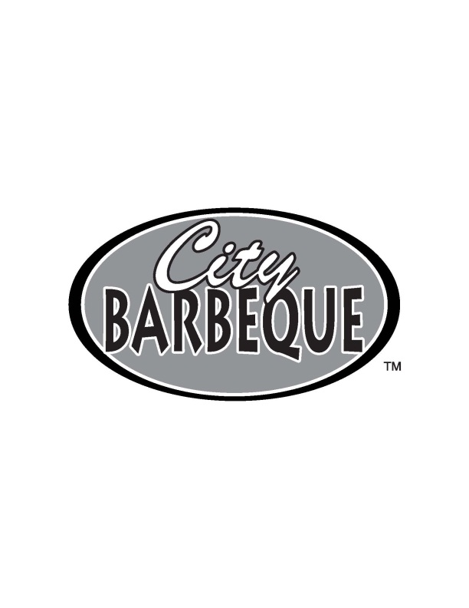Eat at City Barbeque and raise money for our group!
Please join us for a special fundraising event.

25% of your purchase will be donated back to our group!

Name of group: Honor Flight Dayton, Inc.
Date of fundraiser: August 14, 2014
Participating Location: Beavercreek City Barbeque

Good all day on Dine In & Carry Out Orders
Note: If ordering carry out for large groups, please use our Pig Up ‘n Go Menu.
Flyer must be presented at time of order to receive credit for the sale.

Flyers cannot be passed out on City Barbeque property. Fundraiser cannot be combined with
other promotions or offers. Not valid on gift card purchases.
Sale Amt:

$________
Find us & Check out our menus at www.citybbq.com
We look forward to serving you to help raise money for your organization!

Eat at City Barbeque and raise money for our group!
Please join us for a special fundraising event.

25% of your purchase will be donated back to our group!

Name of group: Honor Flight Dayton, Inc.
Date of fundraiser: August 14, 2014
Participating Location: Beavercreek City Barbeque
Good all day on Dine In & Carry Out Orders
Note: If ordering carry out for large groups, please use our Pig Up ‘n Go Menu.
Flyer must be presented at time of order to receive credit for the sale.

Flyers cannot be passed out on City Barbeque property. Fundraiser cannot be combined with
other promotions or offers. Not valid on gift card purchases.
Sale Amt:

$________
Find Us & Check out our menus at www.citybbq.com
We look forward to serving you to help raise money for your organization!

